The weekly 30-year fixed rate mortgage (FRM) on Feb 1, 2024, was 6.63%. This is an increase of 356 bps since the end of Nov-21 when it was 3.07% but just 36 bps higher than this time last year (6.27%). Concurrently, the year-over-year home price gains through Dec-23 for the 20 CBSAs tracked by this report (the CHTR 20-city index) have slowed down but remain positive at 2.94%. Table 1 shows the deceleration of housing.
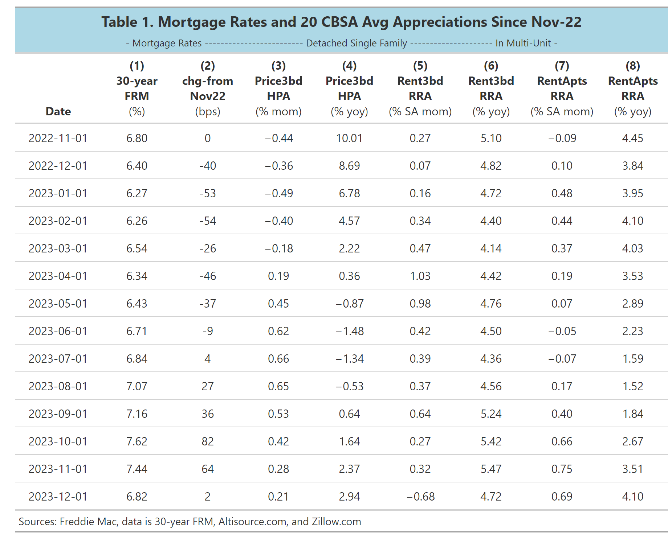
Do declines in home prices filter into the rental market. First it must be pointed out that month-over-month rent growth (Rent3bd column 5 and RentApts, column 7 have been seasonally adjusted). We see evidence of rent appreciation (RRA) mimicking (HPA) during the summer months. There is also evidence that growth in rents on SFR detached properties appears to be a leading indicator of CPI-Shelter. The year-over-year growth in rents for 3-bedroom detached properties is 4.72% which suggests the shelter cost of CPI is not going to fall below 4.00 percent anytime soon.

We also see in column 9 that YOY growth in rental rates on apartments in multi-unit structures is still positive and now growing at a faster rate (4.10% vs 3.51% last month). To get a micro-sense of how rents are changing with prices, Chart 1 shows both the month-over-month increases in home prices (HPA) and in rental rates (RRA) as of Jan-23 for our 20 CBSAs.

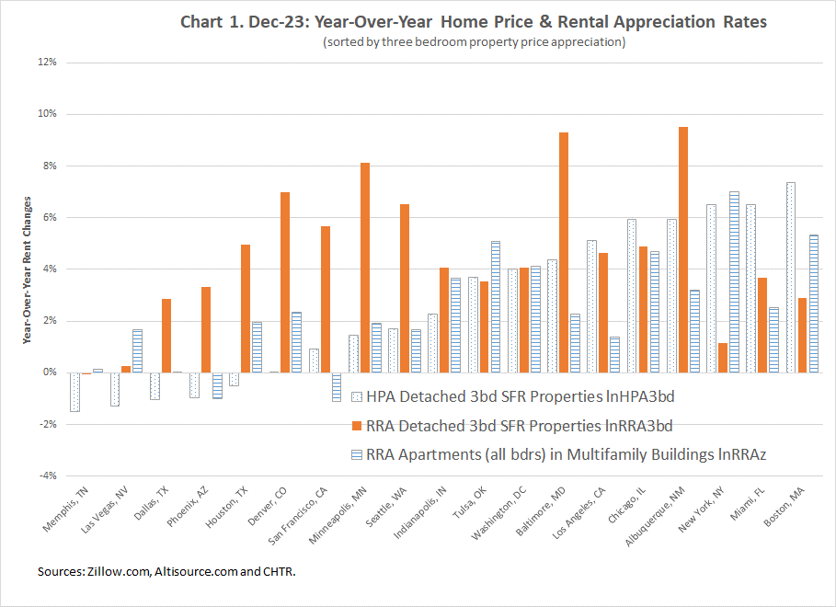
The chart shows that RRA loosely rises with HPA as we move to the right. The red bars show the significant rises in rental rates for 3-bedroom property and the much slower rises for rents of apartments in multi-unit buildings.

In the face of higher mortgage rates, there are some reasons for the still amazingly steady home price growth we see in Table 1.
- Migration out of high-priced California
- Migration out of Central and South America to Miami
- The job market remains very strong
- Millennials moving into their childbearing age and trying to get out of their parent’s houses.
Because vacancy rates are low, the changes in rents for 3 bedroom detached properties and apartments that we see in Table 1 and Chart 1 are probably not due to seasonality. Rents are likely to stay high because:
- Vacancy rates are low, despite the increased purchases of homes.
- Landlords have pricing power.
- Apartment renters might have low incomes and weak credit and may have no other choices but to pay higher rents
Individual CBSA rental markets:
Although slowing, these still high rental prices may continue. It depends, in part, whether renters can afford these increases and on the ability of landlords to increase rents in order to offset rising purchases prices for homes. The rule of thumb is that a household should allocate about 30 percent of income to shelter. To partially answer this question, we show four additional charts below. The first (Chart 2) is for three-bedroom detached properties and the second (Chart 3) is data for apartment rental (all unit sizes) in multi-unit buildings.
Chart 2 shows that in major CBSAs, like Los Angeles, CA, New York, NY , Miami, FL and San Francisco, CA renters are willing to allocate more than 60 percent of their income to renting a three-bedroom property.
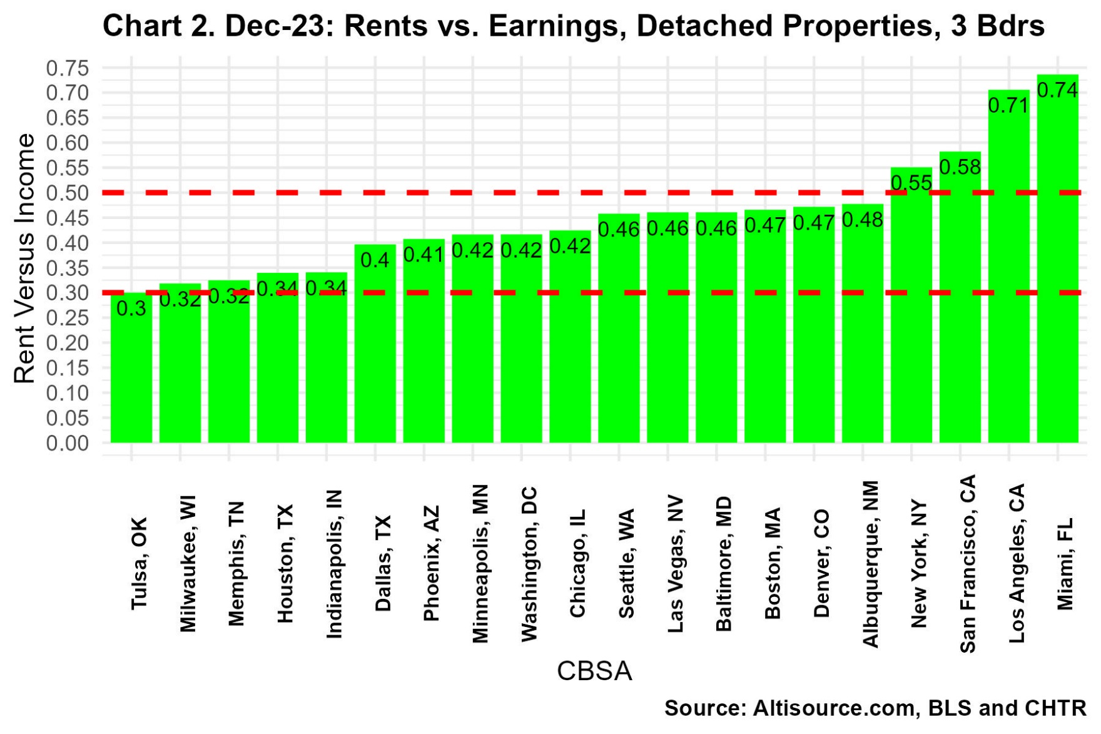

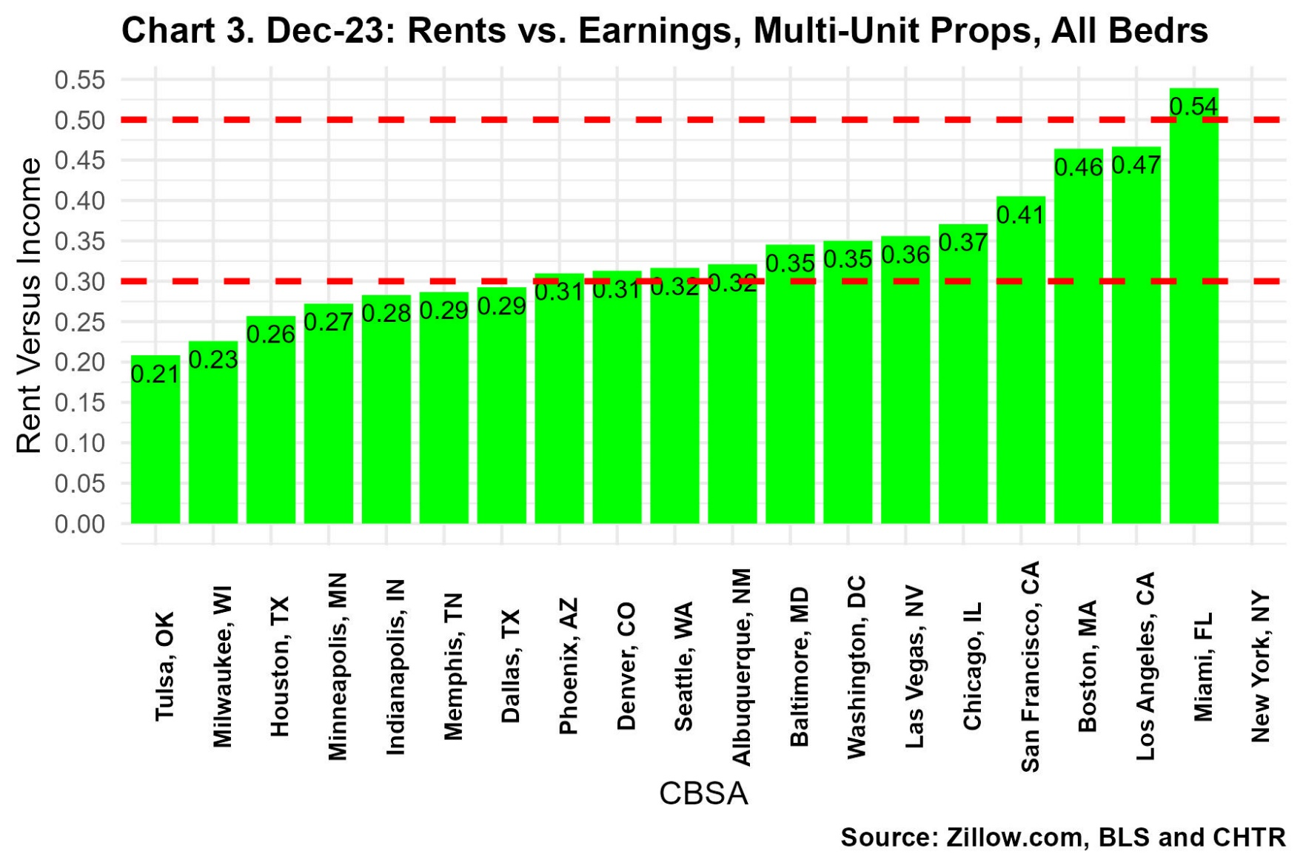This suggests that renters in other cities may continue to pay up to live where they are living or choose to rent a smaller property or move to locations where rents are cheaper.
But the rental markets are changing differently in each city. Chart 4 shows the changes in RVY for renting a 3-bedroom property from Aug-21 to Dec-23 (the same values as in Chart 2 are in the numerator). We see that in the cities on the right, renters are considerably worse off than in the time before the Federal Reserve began increasing mortgage rates.
Renters are now paying more than 4 percent more of their income to pay their rent in at least four cities than they were on Aug-21. On the left-hand-side of the chart renters are paying less out of their income.

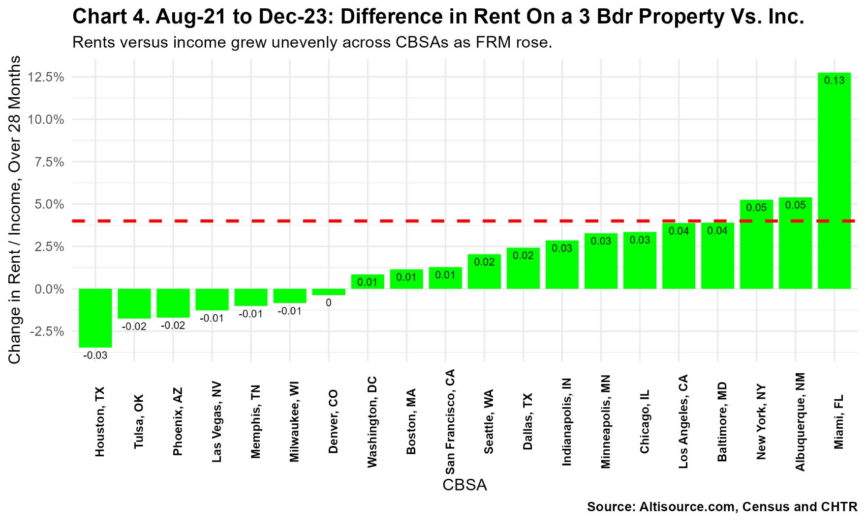

The increased economic hardships now facing renters show up even more so in Chart 5. In that chart, we see that renters of apartments in 6 of the 20 cities that we track are now paying significantly higher rents relative to their income than they had been paying before the rates rose in Aug-21.



