The 30-year fixed rate mortgage (FRM) ended on October 26, 2023, at 7.79%. This is an increase of 472 bps since the end of Nov-21 when it was 3.07%. Concurrently, the year-over-year home price gain through Sep-23 for the 20 CBSAs tracked by this report (the CHTR 20-city index) was a positive 2.47% - slow but still positive (Column 4 in Table 1 below).
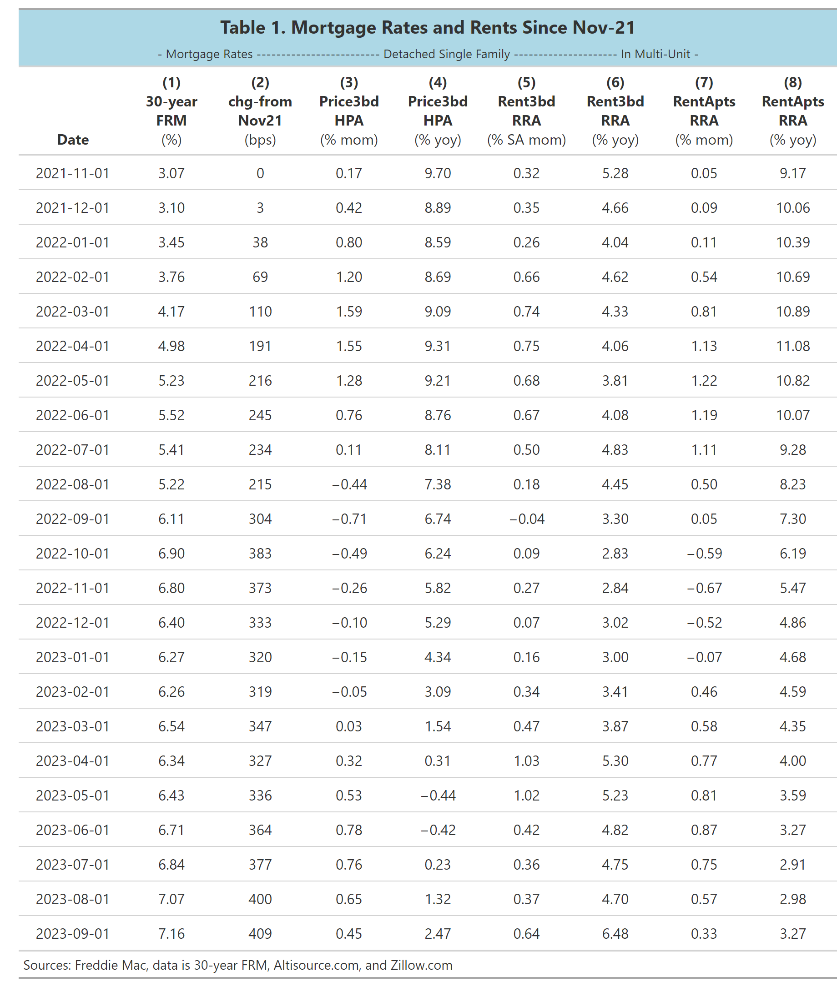
How long does it take for home price declines to filter into the rental market? This is an important question because rents filter into the CPI calculations and there is evidence that growth in rents on SFR detached properties appears to be a leading indicator of CPI-Shelter. The year-over-year growth in rents for 3-bedroom detached properties in Sep-23 was 6.48%. Given the long lag time for the rate changes to filter into the CPI data, this suggests the shelter cost of CPI is not going to fall below 4.00 percent anytime soon.

We also see in column 8 that YOY growth in rental rates on apartments in multi-unit structures is still positive and grew at a slightly slower rate in Sep-23 (3.27% vs 2.98 prior month). To get a micro-sense of how rents are changing with prices, Chart 1 shows the year-over-year increases in both home prices (HPA) and in rental rates (RRA) as of Sep-23 for our 20 CBSAs.

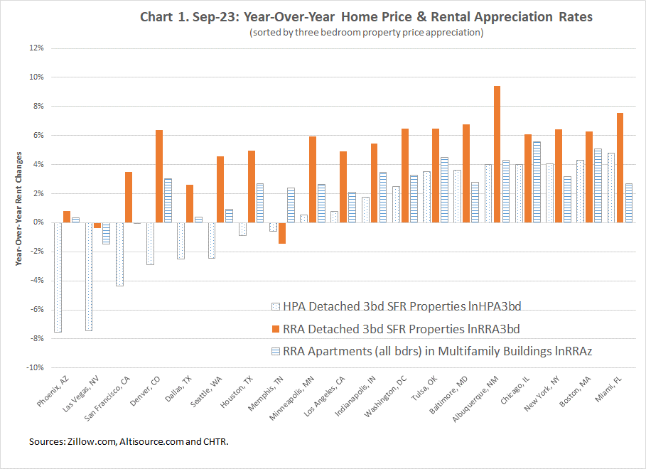
The chart shows that, across CBSAs, RRA does seem to move in-step with HPA. The clear bars with a horizontal line (RRAapt) are small positive values. As we move from left to right, the dotted bars show mostly negative changes and then they turn into positive increase in HPA across CBSAs. The red bars show the significant one month increase in rental rates for 3-bedroom property and the much slower increases for rents on apartments in multi-unit buildings (which have turned upwards again). Higher mortgage rates have deflated the home price bubble, but not the rent bubble. It is important to note:
- It can take three months for HPA to filter into RRA3bd and RRAapt, depending on the city.
- Vacancy rates are low, despite the increased purchases of homes. Landlords have pricing power.
- Apartment renters might have low incomes and weak credit and may have no other choices but to pay higher rents.

Individual CBSA rental markets and earnings:
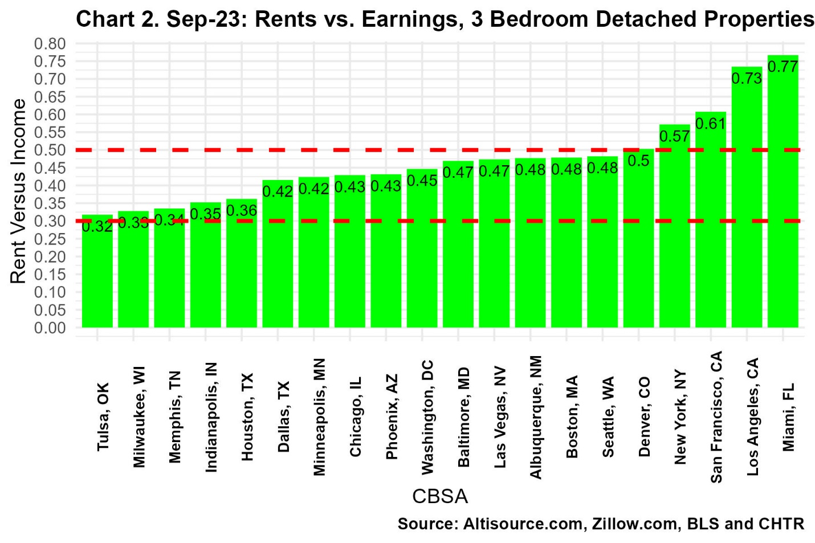
The still high appreciation of rental rate may continue. It depends, in part, whether renters can afford these increases and on the ability of landlords to increase rents in order to offset rising purchases prices for homes. The rule of thumb is that a household should allocate about 30 percent of its income to shelter. To partially answer this question, we show four additional charts below. The first (Chart 2) is for three-bedroom detached properties and the second (Chart 3) is data for apartment rental (all unit sizes) in multi-unit buildings.
Chart 2 shows that in major CBSAs, like Los Angeles, CA, New York, NY, Miami, FL and San Francisco, CA renters are willing to allocate more than 55 percent of their earnings to renting a three-bedroom property.
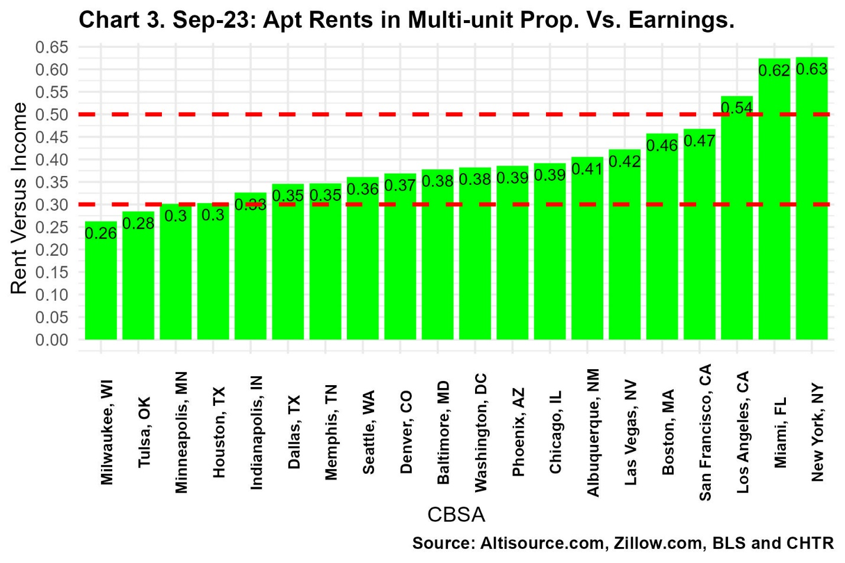
This suggests that renters in other cities may continue to pay up to live where they are living or choose to rent a smaller property or move to locations where rents are cheaper.
But the rental markets are changing differently in each city. Chart 4 shows the changes in RVY for renting a 3-bedroom property from Nov-19 to Sep-23 (the same values as in Chart 2 are in the numerator). We see that in the cities on the right, renters are considerably worse off than in the time before the exogenous Covid-19 health shock.
Many renters are now paying more than 7.0 percent more of their income to pay their rent in at least four cities than they were in Nov-19.
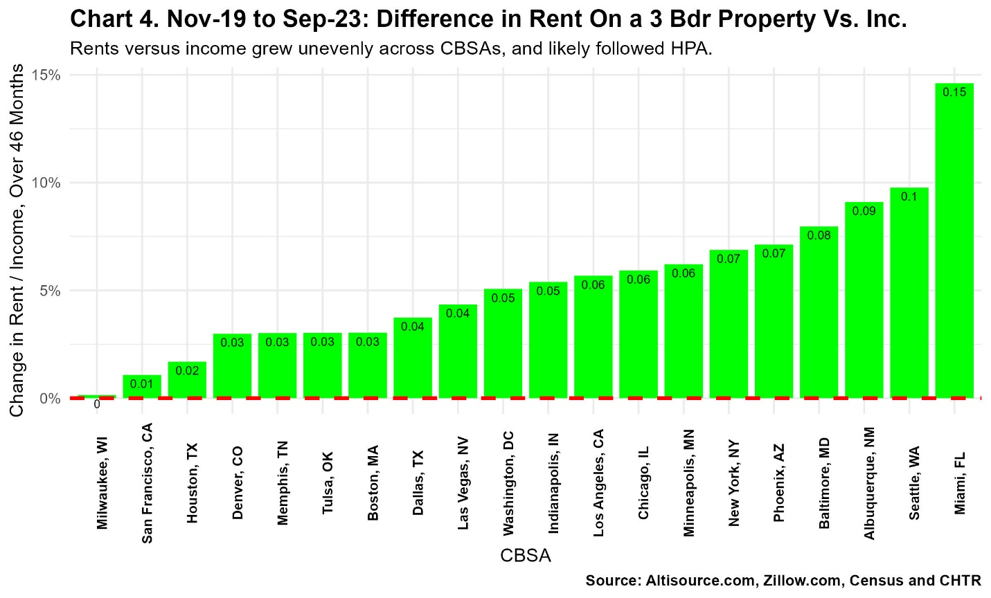

The increased economic hardships now facing renters show up even more so in Chart 5. In that chart, we see that renters of apartments in 16 of the 20 cities that we track are now paying significantly higher rents relative to their income than they had been paying before the rates decline in 2020.


