1. Background
Each state has its own approach to taxation—its own combination of tax types, rates and structures, and rules and exemptions. These variations reflect a multiplicity of purposes and an array of fiscal aims, some with contemporary urgency and others lost to the ages. Yet even the most iconoclastic state tax structures draw upon the federal tax code, and the 2017 Tax Cuts and Jobs Act (TCJA) has ramifications for those tax structures to which, even more than a year out, states have not fully adapted. [1] This report is concerned with how TCJA’s passage influenced FY19 state personal income tax revenue collections (PIT) through each state’s: a) approach to taxations and b) magnitude of personal income tax rates.

Data on federal taxes paid in FY19 by U.S. citizens in each state are not yet available from the IRS. In March 2018, Cushman and Wakefield estimated that TCJA reduced the aggregate federal tax liability of California more than residents of any other state in absolute terms: $33.3B in 2019. [2] This means that if one adds up the federal tax bills of all California households under TCJA and then compares the total to what it would have been under the previous law the bill for FY19 would be $33.3B lower. Texas, Florida and New York will receive the next largest reductions. However, residents in the higher tax rate states will see a smaller reduction in their taxes relative to the incomes; consequently they will bear a larger share of the federal tax burden than they had previously. At the individual level it is estimated that 84% of taxpayers have seen their federal tax bill decline in 2019.

State personal income tax revenue collections for FY19 were recently collected by the Center for Housing Risk Research. The data show that state personal income tax revenue collections went up on average by about 6.3% (i.e., many taxpayers saw their state income taxes go up) over FY18. Absent some sort of policy response, most states saw this increased revenue due to federal tax reform, with expansions of the tax base reflected in state tax systems while corresponding rate reductions failed to flow down. The extent to which this has been true (and indeed in some cases, is not completely true) depends on the federal tax provisions to which a state conforms and the fact that some states also faced increased net-outmigration of their highest income earners due to the motivational aspect of higher effective income tax rates.

Although each has its own additions and subtractions, twenty-nine states and the District of Columbia use federal adjusted gross income (AGI) as their starting point for calculating individual income tax liability. Another six states (Colorado, Idaho, Minnesota, North Dakota, Oregon, and South Carolina) use federal taxable income (FTI). The remaining six states which tax wage income (Alabama, Arkansas, Massachusetts, Mississippi, New Jersey and Pennsylvania) use state-specific definitions (state). Lastly New Hampshire and Tennessee place a tax only on interest and dividends. Seven states do not tax earned income.

Complexity expands as we go from federal rules to state tax rules, and how these rules play out as changes to each state’s PIT revenue collections going forward. One important issue is how a state’s standard deduction usage conforms to federal standard deduction usage. In many states if a taxpayer took/takes the larger standard deduction mentioned above on their federal returns in 2018, it did not have a bearing on whether that taxpayer could itemize versus take the state standard on their state tax return. Most states do allow itemized deductions regardless of the decision on deductions at the federal level. Twelve 12 states and Washington, D.C., however, will allow you to itemize on your state tax return only if you itemize on your federal returns. This has implications on how personal income tax collection revenues to each state have changed in FY19 and will change in the years beyond from prior years. Those 12 states are Colorado, Georgia, Kansas, Maine, Maryland, Missouri, Nebraska, North Dakota, Oklahoma, South Carolina, Utah and Virginia. It is important to point out that 10 of these 13 geographies use AGI as the starting point and three states (Colorado, North Dakota and Utah) use FTI.

TCJA also removed the personal exemption at the federal level. Six states (Colorado, Idaho, Missouri, New Mexico, North Dakota, and Utah) saw the elimination of their personal exemption due to the new federal law. Three of these states (Colorado, Idaho, and North Dakota) adopted the new standard deduction and eliminated the personal exemption by virtue of their use of federal taxable income as an income starting point. The other FTI states retain their exemptions, either because they conform to a prior year’s IRS tax code (Minnesota) or because they expressly decoupled from federal treatment of the personal exemption (Oregon and South Carolina). In Missouri, a somewhat ambiguous statute was clarified (to affirm the personal exemption’s elimination) as part of a broader package of tax reform facilitated, in part, by the new federal law.

In response to the federal tax law changes above and the higher state taxes that taxpayers in their state would have to pay in FY19 (i.e., the mirror image of higher state tax revenue collections), six states modified their state’s tax code in 2018. Thus in addition to the TCJA explicit changes to the tax codes mentioned above we need to consider the subsequent state response, and lastly the impact state marginal tax rate have on net-outmigration of their highest income earners. High net-outmigration of the highest income earners would act to depress tax revenue collections. In essence, this is the impact of TCJA on federal tax returns and the second order impact on each state’s PIT revenue collection. We might, therefore, think that each state has four moving pieces in addition to their economy that could explain their FY19 PIT changes going forward. We address the first two in Sections 2.a through 2.e. We address the 2018 modifications to the tax code in Section 2.f and the impact of federal changes via TCJA in Section 3.

2. State Conformity Breakout
In order to understand state tax conformity and TCJAs impact on state income taxes we block our 50 states and Washington, DC into five different state cohort:

2.a (state-defined)
There are six states which tax wage income that use state-specific definitions of income, although they incorporate some IRS tax code (IRC) provisions into these definitions. These six states again are Alabama, Arkansas Massachusetts, Mississippi, New Jersey and Pennsylvania. Because they rely the least on IRC, they are likely to be the states least impacted by TCJA (labelled in the Chart 1 below as state).

2.b (AGI, SD=fed)
A state electing AGI as a starting point for it definition of income tax liability means that the definition of taxpayer’s income liability has not been directly impacted by TCJA. However, TCJA’s impact on state tax revenue collections filter down in other ways. Nine states and the District of Columbia electing AGI require that if a taxpayer takes the standard deduction at the federal level, the taxpayer must take it at the state level (labelled in the Chart 1 as AGI, SD=fed).

TCJA increased the federal standard deduction, which resulted in more taxpayers taking the standard deduction rather than itemizing deductions at the federal level. On average, taxpayers who itemize at the State level pay a lesser share of their income in PIT than those who take the standard deduction. As a result, the average taxpayer who switched from itemized deductions to the standard deduction paid more in state PIT. In prior years about half of Maryland taxpayers took itemized deductions, in TY 2018 only a quarter did. Generally, switching to the standard deduction meant lower refunds or sometimes a final payment for those taxpayers. These nine states most likely witnessed state PIT collections in FY19 going up relative to FY18 more than the other AGI states. It should be pointed out here that three states use federal taxable income as the starting point also incorporate the federal standard deduction rule (Colorado, North Dakota and Utah). These three states will be discussed below.

2.c (AGI)
Twenty-nine states and the District of Columbia use federal adjusted gross income (labeled AGI) as their starting point for calculating state individual income tax liability. For these states, TCJA changes do not impact the starting point to calculate an individual’s state income tax liabilities. As noted above, however, 9 states and DC start with AGI and also require their taxpayers to use the standard deduction at the state level when they use it at the federal level. This leaves 19 AGI states in which taxpayers are free to itemize their deductions at the state level even if they take the standard deduction at the federal level. The impact of TCJA on tax revenue collections in these 19 states is not easy to predict. Moreover, many of the states with the highest marginal income tax rates fall into this cohort (including New York, Connecticut and California). TCJA changes to the tax codes states exaggerates the impact each state’s marginal tax rate has on net-outmigration. These states may see state PIT collections in FY19 go up or down relative to FY18.

2.d (FTI)
Six states (Colorado, Idaho, Minnesota, North Dakota, Oregon, and South Carolina) use federal taxable income. A state electing FTI as a starting point for state income taxes has the effect of incorporating federal standard and itemized deductions and a new deduction for qualified pass-through business income, unless the state expressly decouples from these provisions. Since the federal personal exemption (FPE) now set at $0, is also an element of federal taxable income but not federal adjusted gross income, states which begin with federal taxable income incorporate the elimination of the personal exemption unless they expressly decouple from the provision, while for other states, the implications of federal repeal vary depending on how state statutes are written. Three of states that use FTI as the starting point retained their personal exemption (Minnesota, Oregon and South Carolina). Eliminating the personal exemption at the federal broadens the tax base considerably more than raising the standard deduction narrows it, we would expect to see state tax revenues go up even more in the FTI states than the AGI and state-define states (labelled as FTI in Chart 1 below).

2.e (FTI, SD=fed, FPEe)
Two of the six states above which use FTI as the starting point for income tax liability also mandate that if taxpayers take the federal standard deduction that they must also take the standard deduction on state calculations and along with Idaho have simultaneously in 2018 have lost the federal personal exemption and consequently the state personal exemption (or, the state personal exemption eliminated, labelled as FPEe in Chart 1). These two changes mechanically bring more taxes into those State coffers. We consequently put Colorado, Idaho and North Dakota into a fifth category. Eliminating the federal personal exemption broadens the tax base considerably more than raising the standard deduction narrows it, we would expect to see state tax revenues go up even more in these three FTI states than other states.

2.f. State responses (Tax decr)
Recognizing that there are other moving pieces, does not change the fact that for most states, the tax base is broader after federal tax reform, forcing states to decide whether to keep the additional revenue to grow government, cut rates to avoid an automatic tax increase, or use the broader base to help pay down broader tax reform. In 2018, seven states—Georgia, Idaho, Iowa, Missouri, Utah, and Vermont—adopted rate cuts or other reforms designed, at least in part, as a response to the expectation of increased revenue due to federal tax reform. Their distinct approaches pattern a range of options available to other states. These were:
- In Georgia, lawmakers reduced the top individual and corporate income tax rates from 6 to 5.75 percent in 2019 while doubling the standard deduction. Further rate reductions, to 5.5 percent on both taxes, are anticipated for 2020, but will require a joint resolution affirming the legislature’s continued assent. The bill was signed into law on March 2, 2018.
- Idaho implemented a 0.475 percentage point cut in the corporate income tax rate and across all marginal individual income tax brackets in 2018 and introduced a new child tax credit to offset additional revenue associated with federal tax conformity. The child tax credit was created to account for the impact of the loss of the personal exemption for larger families. The law passed in June 2018.
- Kentucky in April 2018 replaced the individual tax brackets with a single 5 percent tax rate. Previously Kentucky had tiered brackets of 5, 5.8 and 6 percent. To offset the flat tax rate, lawmakers eliminated a number of individual deductions, including those for health insurance coverage and medical expenses. Although there are fewer options for itemized deductions, the standard deduction remains at $2,530.
- In Missouri, the top individual income tax rate was cut from 5.9 to 5.4 percent, partially offset by a phase-out of high earners’ federal deductibility, and a corporate rate cut is set to follow in 2020. As in Iowa, a broader tax package was facilitated in part by federal conformity revenue, particularly since the state conformed to the repeal of the personal exemption. The new tax rate became effective January 1, 2019.
- Utah shaved its individual and corporate income tax rates from 5.0 to 4.95 percent and approved an expansion of the child tax credit to offset additional revenues expected from tax conformity. The law became effective January 1, 2020.
- Vermont eliminated its top individual income tax bracket and reduced the remaining marginal rates by 0.2 percent across the board.
- A broader tax reform package advanced in Iowa, helped along by projected conformity revenue. Over the course of several years, Iowa’s top individual income tax rate will fall from 8.98 to 6.5 percent, while the corporate income tax rate will decline from 9.8 percent. The tax package includes the repeal of the alternative minimum tax as well as the phase-out of Iowa’s unusual deduction for federal taxes paid. The law passed on May 30, 2018, but its gradual introduction means its impact was not felt in FY19.

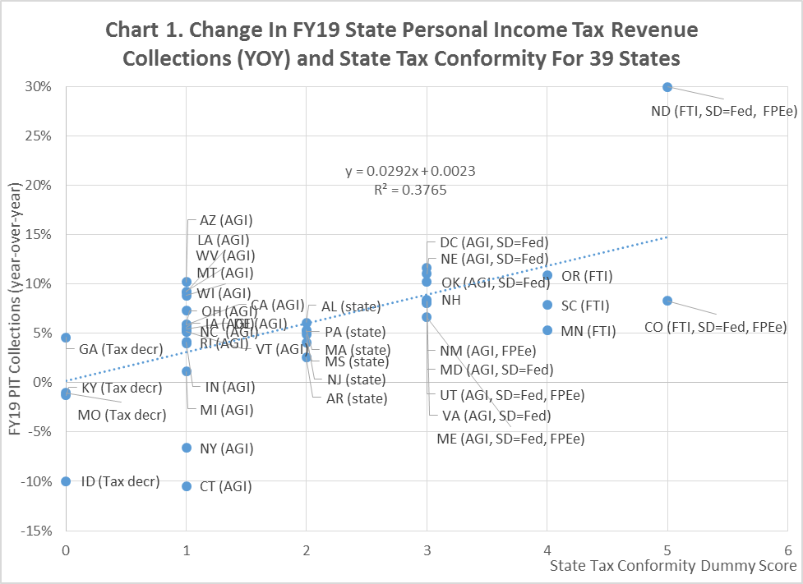

These four states of Idaho, Georgia, Kentucky, and Missouri appear on Chart 4 as states with a decrease to their state income tax rates (dummy value equal to zero). The tax changes for Vermont, Iowa and Utah apply to FY20. Table 1 shows the state tax conformity breakout.

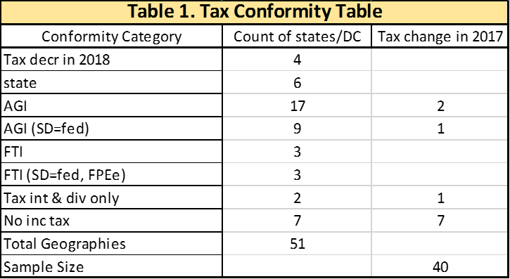

3. The impact on FY19 state income tax revenue collection
TJCA is a federal tax law change, but its second order effects have driven changes to state tax collections. It does this through: 1) altering the impact of state tax laws (i.e., state tax conformity drives secondary tax revenue effects) and 2) increasing net-outmigration from high SALT states (a federal tax law secondary effect) which also drives state tax revenues.

3.a State income tax revenue collection data
We are looking for the impact TCJA had on TY18 tax collections which would show up in FY19 PIT collections over FY18. As we will highlight in Table 3, we are using calculated average state tax rates from 2016 and only want states in our sample whose tax rate structure remained unchanged from 2016.

Four states altered their tax rate structure in 2017:
- Hawaii reintroduced a peak marginal income tax rate of 11%, up from 8.25%, on all income over $200,000 for single filers. This peak rate was instituted in 2009 as a temporary tax increase, but it expired in December 2015.
- Illinois passed a 32% increase to its individual income tax rate, from 3.75% to 4.95%. However, the increase was designed to be blended in during 2017 and enacted fully in 2018. In plainer terms, Illinois residents paid 3.75% for the first half of the year on their earned income and 4.95% for the second half of 2017. Meanwhile, in 2018, they paid a 4.95% in state income tax on their earned income.
- Kansas increased its state income tax in 2018 by 0.2% (2.7% to 2.9%) for those earning $30,000 or less, 0.3% (4.6% to 4.9%) for those making between $30,001 and $60,000, and 0.6% (4.6% to 5.7%) for folks making more than $60,000.
- Although Tennessee forgoes a wage income tax, it does as mentioned above impose a tax—called the Hall Income Tax—on interest and dividend income. That tax is being phased out with the rate dropping from 4% in 2017 to 3% on January 1 in 2018.
These four states were dropped from our sample because we are trying circumvent any changes in 2018 net-migration caused by individual state tax rate changes.

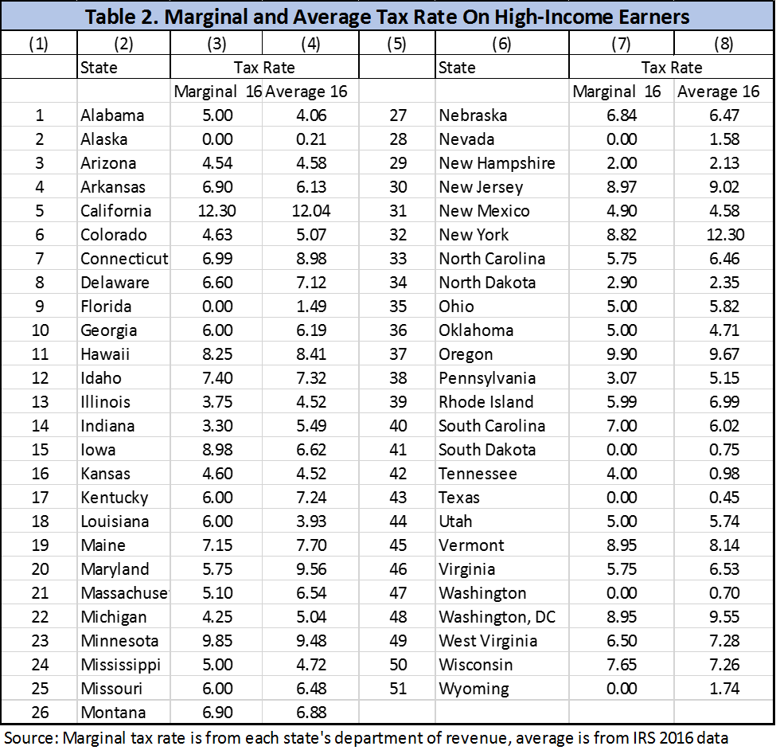

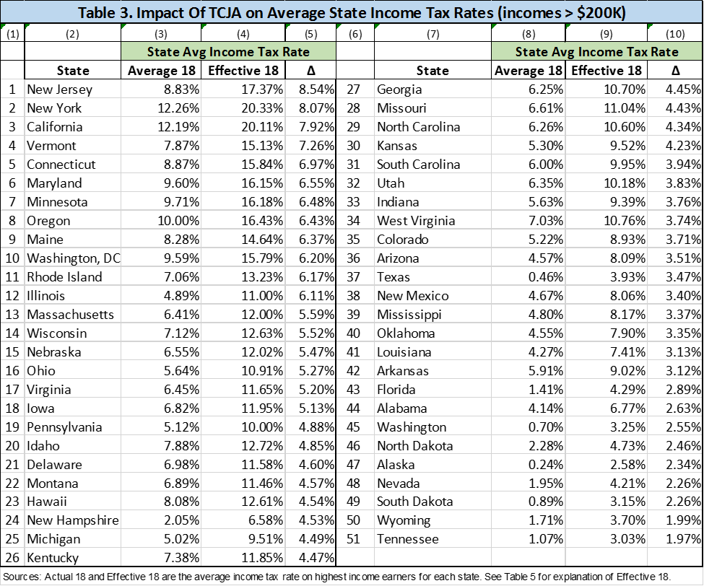

We are trying to isolate the changes caused in 2018 by TCJA. By including the District of Columbia, and New Hampshire, we are left with 40 markets in which income tax rates were static from the prior two years. This would be for the fiscal year 2019 (FY19). Finalized state FY19 PIT tax revenue data became available in October 2019.

We need first to know each states’ individual income tax rates. There are two approaches. Table 2 shows two ways of assessing each state’s income tax rate. The first is the marginal tax rate of each state’s highest income bracket. These are the rates quoted to tax filers. These marginal rates in columns 3 and 7 are for the year 2018. We can easily obtain state marginal tax rates for the highest income bracket, but these do not reflect what taxpayers actually pay.

A second approach is to calculate average tax rates. In columns 4 and 8 are calculated average state and local tax rates for citizens living in that state. The ‘Average 18’ series of income tax rates (columns 4 and 8) are shown for taxpayers with incomes greater than $200k using data from the IRS’s county-level income database. It is calculated as the total amount of state and local income tax paid by all taxpayers with incomes greater than $200k in a given state divided by the aggregate income of taxpayers in that income bracket in the year 2018. It includes local taxes because they have to be paid also. These IRS tax rates are calculated averages from the IRS 2018 database. Again, they include income taxes paid to both the local jurisdiction and the state. Since some taxpayers in states which have a zero state income rate pay some local taxes, the calculated actual and effective state tax rates show up with small positive values due to the local income taxes paid. They are not stated marginal rates. In columns 5 and 10 of Table 3, we show our estimates of how much higher the effective income tax rate is for the highest tax bracket following passage of TCJA (the delta). The states with the highest actual marginal rate suffer the biggest jump in the effective state income tax rate. In Table 6, we explain our reasoning.

3.b Income tax rates and the change in income tax revenues for FY19
To measure the impact on PIT tax revenue collections, we went to each state’s website to collect personal income tax revenue collection for both FY18 and FY19. We then calculate the year-over-year change. The results are in Table 4.

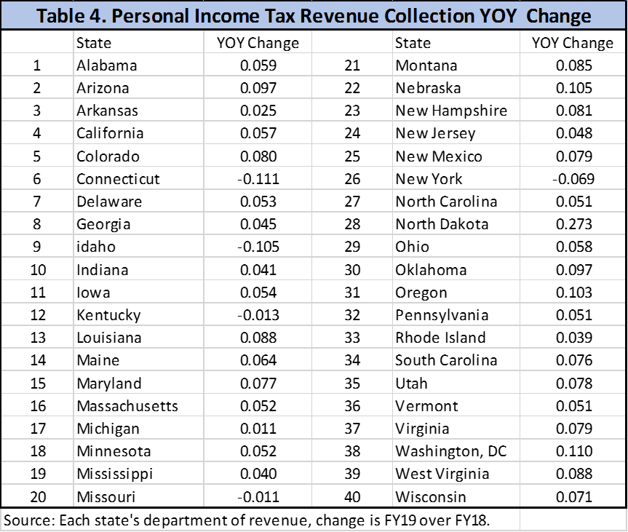
We notice in Table 4 that the collection of personal income tax revenue declined for several states while most others increased in FY19. We noted in Section 2 that some states their lowered their income tax rate as a way to mitigate anticipated higher tax payments by their citizens. It is true that the local economy in each state varies and some states have more high-income taxpayers, but in this section we consider the effect of each state’s income tax rate on the location decision of it highest income earners. Here we use the IRS’s cutoff of incomes greater than $200k to define high-income.

In Chart 2, we plot the TCJA deltas (the change in the effective income tax rate for individual with income greater than $200k, columns 5 and 10 of Table 3) against the year-over-year change in FY19 income tax revenue collections (YOY, FY19 over FY18) for 39 states and Washington, DC.
In that chart we see a number of important facts:
- The YOY PIT changes averaged a positive 6.1 percent for the 40 geographies. If we ignore North Dakota, Idaho, New York, California, New Jersey and Connecticut in Chart 2 we could say that states were not impacted by TCJA. There does not seem to be much of an impact at mid-range deltas. Having said that, we see that the states with the biggest declines in income tax revenue collections were those with the biggest delta to their effective income tax rate (these would be those the states with the highest state and local tax rates). Again, New York and Connecticut are the stand-out states in this category.
- Overall, the relationship between income tax revenue growth in FY19 and the TCJA delta is negative. The higher effective income tax rates in high-income tax rate states has likely motivated some high-income taxpayers to leave those states. Leaving the state is not just declaring primary occupancy in a different state.[3] These high-income migrants must have organized themselves during the year prior to passage. This raises the question of burnout.
- New Hampshire, which only taxes investment income, witnessed an 8.4% increase in income tax revenues. This suggests that the stock market changes in 2018 were largely positive for high-income investors. Investors from other states probably experienced the same gains as investors from New Hampshire.
- Two states (Oregon and Maryland) and Washington, DC which had their income tax rate impacted nearly as much as Connecticut did not suffer major declines in income tax revenues. Why not? Maryland and Washington, DC mandate taking the standard deduction at the state level if a taxpayer is taking it at the federal level. This has meant higher income tax receipts. Anecdotal evidence also suggests that some financial firms prominent in NY & CT) are moving out, perhaps they can move more easily than industries with more tangible assets or those who need to be close to the government physically. Oregon is a FTI state.
- The state of New Jersey is another interesting standout. It has the highest TCJA delta due to its high income and property tax rates, but its PIT change of 4.7 percent is only slightly lower than the average. Why would taxpayers in New Jersey respond differently than those in New York? The data in Chart 4 shows that New Jersey uses a state-defined measure of state income tax liability. Essentially, PIT revenues came in stronger in New Jersey (versus New York, or Connecticut) even though New Jersey’s high income and property tax rates are motivating high-income taxpayers to leave the state because the state’s state-define income tax liability was not significantly distorted by TCJA.
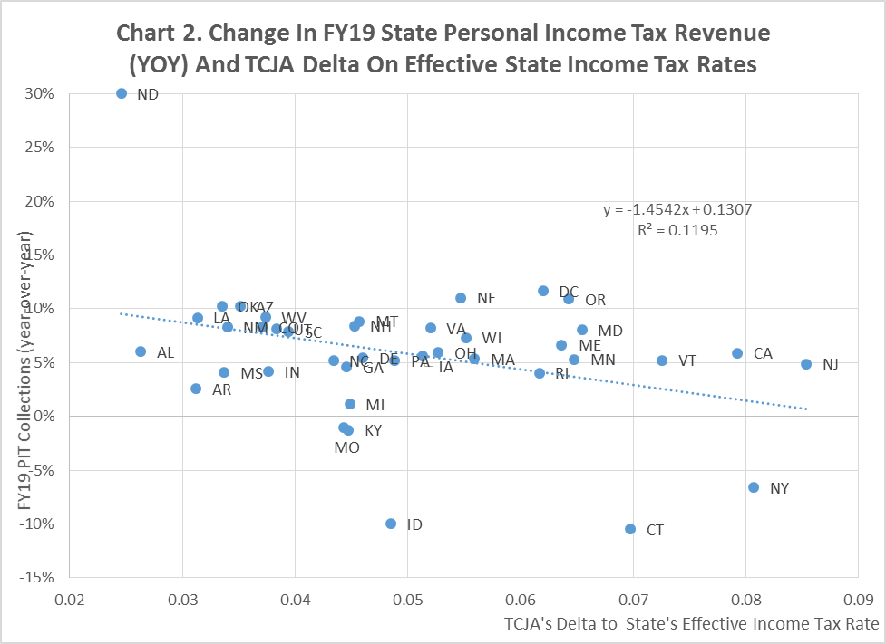

4. Empirical evidence on what drove FY19 income tax revenue collection changes
To investigate the proposition that TCJA drove changes in states’ personal income tax (PIT) revenue collections from FY18 to FY19 through the impact it had on each states’ effective income tax rate and then on net-outmigration versus the strength of each state’s economy, we use a difference-in-difference approach on FY19 PIT data as shown in Equation 1. In Equation 1 we include the variable CONFORM as a state dummy variable explaining each states unique taxing structure. So TCJA (the delta’s from Table 3) captures the second-order impact at the federal level while CONFORM captures the second-order impact at the state level.

PITi = α + β1 * CONFORMi + β2 * EMPi + β3 * TCJAi + µi (1)

Where PITi = percentage change in personal income tax revenues collected in FY19, or (FY PIT - FY18 PIT)i / (FY18 PIT)i ) for 39 states and Washington, DC; TCJAi is the difference in effective income tax rate, or Effective 18 – Actual 18 (the delta as shown in Table 3); CONFORMi is a dummy variable for state income tax conformity and EMPi is the two-year payroll growth. We do this for 39 states and Washington, DC.

We can modify Equation 1 slightly by using the average state income tax rate as an instrumental variable for TCJA. This makes for an easier interpretation of the elasticity.
PITi = α + β1 * CONFORMi + β2 * EMPi + β4 * INCOME TAX RATEi + µi (2)

Here, INCOME TAX RATE is the state average income tax rate (Average 18 in Table 3).
The results are in Table 5. By limiting the independent variable to just CONFORM (Equation 1.a), we observe that a state’s income tax structure drove much of the changes in the percentage change in tax revenues. This one variable explains 37% of the variation in state tax revenue collections.

Moving to Equation 1.c, we note that the higher a state’s income tax rate was in 2018 (and consequently the bigger the impact of TCJA (the delta)), the smaller was the state’s increase in personal income tax revenues collections in FY19. The coefficient β3 is our income tax rate delta elasticity (εΔ). The value of -1.37 indicates that for every 1% higher that TCJA bumps the effective income tax rate, the state’s FY PIT came in lower by 1.37%. The TCJA explains an additional 9% of the variation.
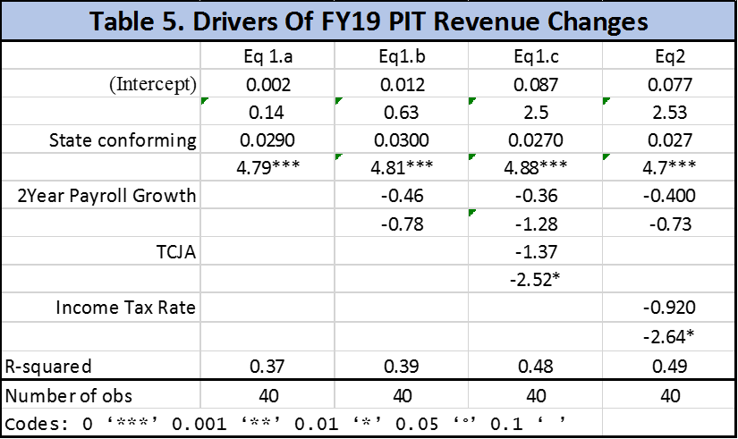

However, moving to Equation 2, we note that the higher a state’s average income tax rate was in 2018 (and consequently the bigger the impact of TCJA (the delta)), the smaller was the state’s increase in personal income tax revenues collections in FY19. The coefficient β4 is our income tax rate elasticity (εr). The value of -0.92 indicates that for every 1% higher a state’s income tax rate is higher than other, the state’s FY PIT came in lower by 0.92%. The income tax rate explains an additional 10% of the variation.
This specification suggests that impact of the TCJA bump (the delta) on income tax revenue collections, simultaneously driven by each states’ tax structure, depends upon the magnitude of that state’s combined 2018 SALT taxes. Roughly for those states with a stated marginal income tax rate greater than 9 percent in 2018 for taxpayers making more than $200k per year, TCJA, in effect, raised their average state income tax rate by 7.0 percent (Table 3). This according to Equation 1.c indicates that net-outmigration has become high enough to cause income tax revenues to be lower than the average or even decline. Onerously for high SALT states, the TCJA delta is not going to go away and evidence indicates the resulting net-outmigration delta, every year, each year, slows down only slightly, but also never goes away.

5. Conclusions
The 2017 Tax Cuts and Jobs Act has radically altered tax revenue collections in the U.S. As many economists have advocated, the removal of the MID and SALT deductions reduces the distortion to overconsume housing. However, it is an external shock to migration, housing and tax revenue collections. It has changed the incentive to own a house and where to live.
We are trying to answer five important questions:
- How much does net-outmigration increase due to a 1% increase in a state’s income tax rate?

- What might happen 3, 4, or 5 years after the tax law change? Does net-outmigration burn itself out, or does it grow over time?

- How much has TCJA altered state income tax revenues through state tax conformity?

- How much has TCJA raised effective tax rates?

- How much has TCJA altered high SALT states’ income tax revenue collections in FY19 through net-outmigration of high-income taxpayers impact state income tax revenues?

In looking at prior research and the results of this paper, these are our observations:
- Net-outmigration: Empirical evidence indicates that a one percent higher income tax rate causes net-outmigration to jump on average by 100 high-income taxpayers per 100,000 high-income taxpayers in the first year (Haidorfer and Sussman, 2020). Moretti and Wilson (2017) suggests that net-outmigration for very high income earners is even larger. The results from both pieces of research are empirical averages. Our research covers households making more than $200k per year in 2016 - 2018 based on 50 states and Washington DC.
- Burnout: The evidence is that the impact of these types of shocks do not burn themselves out quickly. Historical data from the states that have raised their income tax rates at least once in the period from 2012-2018 indicate that the jump in net-outmigration remains as long as five years past the initiation of an external shock like TCJA. This evidence from earlier periods using IRS data for five states, supplemented by academic research using data from other sources indicate that, at a minimum, any increase in the net-outmigration rate above what it was in the year before the income tax rate increase remains steady. This happened at least four years after the initial shock. There is only slight burnout as net-outmigration remains elevated. Competing evidence suggest a rising impact.
- State tax conformity and income tax revenue collections: Many individuals in America paid less federal taxes in 2018 than they did in 2017, a beneficial outcome, all else held equal. However, some individuals paid less federal taxes and more state income taxes. This is good for the state and bad for taxpayers. The point is that TCJA impacted not just federal income tax collections, but also state income tax collections.
- Effective average tax rates: Our observation on how much TCJA has raised average effective income tax rates in each state is in Table 3 (also see Table 6 in the Appendix for explanation).
- Federal tax changes and income tax revenue collections: TCJA has raised 2018 effective income tax rates for all states that have an income tax. Using an unique dataset on recently released FY19 state personal income tax revenues we have estimated an elasticity on the TCJA interest rate delta (εΔ) equal to -1.37. Thus empirically, according to our linear specification, for every one percentage point that TCJA has raised the effective state income tax rate on its highest income earners we show that a state’s personal income tax revenue collections come in at a 1.37% slower rate. But inspection of Table 3 and Chart 2 indicates that tax revenues gains become significantly slower than average once a state’s average personal income tax rate (state and local combined) is greater than 9 percent (corresponding to a TCJA delta of 7 percent).

The downside of TCJA is that it penalizes states that have high income tax rates while changing little for states that have no income tax. By increasing effective tax rates in high SALT states it is hastening net-outmigration. Although we do not have net-outmigration data for 2019 to prove this hypothesis, Haidorfer and Sussman (2020) show that home price growth is faltering and income tax revenue collections have weakened in states where taxpayers previously enjoyed high SALT deductions.

The data underlying Equation 2 show that TCJA is causing income tax revenues to decline in high SALT states. Rising net-outmigration could overwhelm a states’ ability to mint new taxpayers. This dynamic is likely to lead to further declines in state income tax revenues in states with high marginal income tax rates. It could also lead to a decline in property prices and property tax revenues, perpetuating a vicious cycle in those states in the absence of policy readjustment by each state.

Appendix

In Table 6 below, we start with three identical households, one of which are living in, respectively, New Jersey, Illinois and Florida. Each household is making $500k and has owned the home since 2018 with a purchased price of $2.0 million by using a mortgage. We go through the 2018 income tax calculations in columns 2 through 4. Each has made a 20% downpayment of $400k. We use a mortgage rate of 4.0%. This yields an annual mortgage payment of 64,000 on a $1.6 million mortgage. In 2018, each of these homeowners could have taken a mortgage interest deduction on $1.0 million mortgage (row 6). This would have been a MID of an amount of 40,000.
The annual property tax rate for NJ, FL and IL are respectively 3.61%, 1.79%, 2.63%. This in 2018 would result in our three homeowners each paying $77,780, $34,200 and $62,800 in property taxes, respectively (row 12). The allowable property tax deduction was not capped so each of these three homeowners would use those amounts as a deduction. Additionally, our homeowners would have had to pay a state income tax if they lived in New Jersey or Illinois but not if they had lived in Florida. We estimate that the New Jersey homeowner would have had to pay $36,388 in state income taxes and the Illinois homeowner would have paid $24,750. Pre-TCJA, all of these payments could be deducted. These amounts would result in our household in New Jersey comparing total SALT and MID deductions of $154.188 to the standard 2018 deduction of $12,700, the household in Florida comparing total SALT and MID deductions of $74,200 to the standard 2018 deduction of $12,700, and the household in Illinois comparing total SALT and MID deductions of $127,550 to the standard 2018 deduction of $12,700 (row 20).
These deductions would have resulted in taxable income falling to $345,813, $425,800 and $372,450 for New Jersey, Florida and Illinois, respectively (row 26). Since the taxable income for all three homeowners was reduced to close to $400k, the 2018 federal tax rate was 35%. This result in federal and state taxes of $235,222, 183,230 and 217,908 in Table 6 for the year 2018 (row 31).
When we do the same exercise under TCJA, all three homeowners decide to itemize rather than take the standard deduction of $24,400 for married couples. This is true despite the fact that the total of itemized deductions for all three households is an identical $40,000 due to the capping of SALT deductions at $10,000. This results in a higher federal tax payment of $39,966, $11,970 and $30,642 in columns 5, 6 and 7 of row 32. Adding these numbers to the 2018 state tax liability results in an effective average state tax rate in 2018 after TCJA of 15.27%, 2.39% and 11.08%. These are the effective 2018 state tax rates (‘effective18’). Comparing the effective18 tax rate to the actual18 average tax rate (the six columns of row 34) yields a delta of 7.99%, 2.39% and 6.11% for New Jersey, Florida and Illinois, respectively (rows 35 – 37). These is the TCJA bump each state faces.

--------------------------------------------------------------------------------------------------------------------
- Much of this report follows directly from the work on state tax conformity “Toward a State of Conformity: State Tax Codes a Year after Federal Tax Reform” by Jared Walczak of the Tax Foundation, January 28, 2019.
- Cushman & Wakefield “Tax Reform in High SALT States” March 2018.
- Transplanting oneself to Florida goes beyond getting a new driver license. According to the Wall Street Journal (January 8, 2020) New York conducted 15,122 residency audits form 2013 to 2017. Of those audits 52% of New Yorkers lost their case costing them an average $144,000 in additional taxes and penalties.

