In December of 2017, Congress passed the 2017 Tax Cuts and Job Act (TCJA). This federal tax law limits the deduction to the home mortgage interest deduction (MID) on the first $750,000 of mortgage debt (reduced from the pre-TCJA limit of $1 million of mortgage debt) for mortgage loans taken out after December 15, 2017. In addition, homeowners may no longer deduct interest paid on home equity loans, unless the debt is used to buy, build, or substantially improve the taxpayer’s home that secures the loan. Homeowners still may deduct mortgage interest on both their primary residence and a second home, as long as the second home is not rented out during the tax year.

The TCJA almost doubled the standard deduction, increasing it from $6,350 for single filers and $12,700 for married couples filing jointly, to $12,000 and $24,400 respectively. Taxpayers also can still deduct state and local real estate, personal property, and either income or sales taxes in 2019 and 2020, but the TCJA capped the total state and local tax (SALT) deduction at $10,000.

Since TCJA severely reduces the SALT and MID deductions, these changes to the federal tax law have markedly raised the average effective state income tax rate paid by citizens in states with high personal income tax rates, like New York, Connecticut, Maryland and Washington DC vis-à-vis other states. Alternatively, however, the tax law change by raising the standard deduction to $24,400 for married couples lowered the overall federal tax bill for many U.S. households in 2018. This had the secondary impact of raising state taxable incomes, and additionally motivating many individuals, even those with low priced homes to no longer deduct their mortgage payment and instead take the standard deduction.

The Tax Policy Center estimates that filers who itemize taxes dropped from roughly 46.5 million under the previous tax code to just 19.3 million under the TCJA. IRS data for 2015 indicates that 29.6 percent of taxpayers filed itemized returns, while roughly 70 percent took the standard deduction. For those homeowners that utilize the standard deduction going forward, the tax benefits of home ownership have been reduced.

A full two years after TCJA passage, the reduced benefits of buying a home are showing up as slower home price growth in the major cities of high SALT states. We can think of two time periods: the 20 months since TCJA passage and the 20 before TCJA passage. In Chart 1, we start the pre-passage period on Jan-16 and run it through Aug-17 and the post-passage period will start Jan-18 and run to Aug-19 (our last data period).

The data in Chart 1 are home price growth rates for high-tier home for 16 cities (or CBSAs, core based statistical areas) from Case-Shiller. The data is seasonally adjusted, but we have calculated HPA for the two time periods over identical months to avoid seasonality issues. Chart 1 highlights that different cities have had different growth rates over both time periods. The more striking observation about Chart 1 is that the growth rate for the post-TCJA experience is lower for 14 of the 16 CBSA. The Chart represents a univariate analysis and it is true that the economy and interest rates were different over those two periods, but a pattern exists which we explore in Charts 2 and 3.

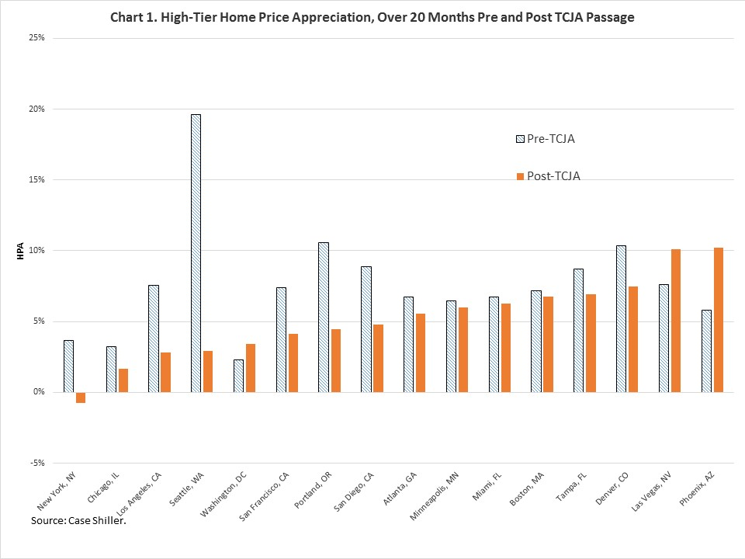

In Charts 2 and 3 we offer potential explanations. Chart 2 maps home price growth for the post-TCJA time period that we saw above in Chart 1 against average property tax rates for those 16 CBSAs. The property tax rates are derived from IRS data for the income cohort in each CBSA with incomes above $200K. These computed property tax rates are average actual rates using 2016 IRS data. They are calculated as the total amount of state and local property tax paid by all taxpayers with incomes greater than $200k in a given CBSA divided by the number of taxpayers in that income bracket in the year 2016. It includes state and local taxes paid by residents of the CBSA because both taxes have to be paid if there is a state and/or local property tax.
In Chart 2, cities with the highest property taxes, which now only partially deductible, are witnessing the slowest home price growth relative to those cities in state with low property tax rates. TCJA has reduced the demand for homes in these cities, and this is reflected in slower home price increases (or even decreases as in the case of New York City). So the loss of the MID deduction has reduced demand for homes.
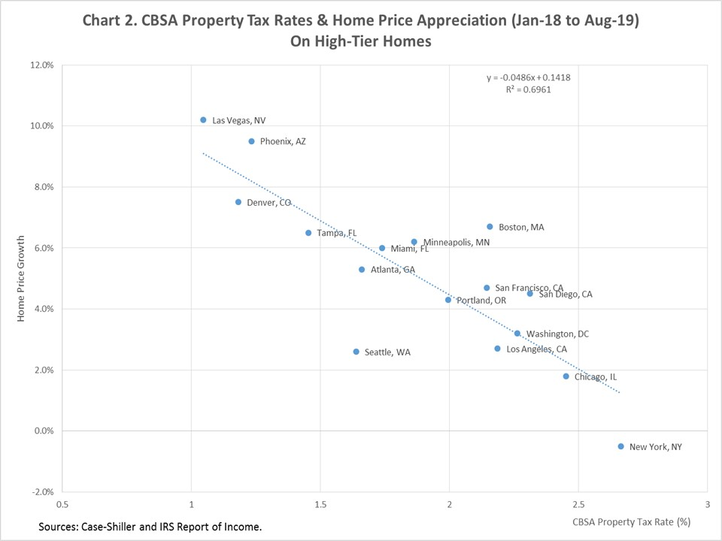

Chart 3 indicates a similar story, but here the driving forces is the income tax rate paid in each city. Chart 3 maps home price growth for the post-TCJA time period that we saw above in Chart 1 against average income tax rates for those 16 CBSAs. The income tax rates are derived from IRS data for the income cohort in each CBSA with incomes above $200K.
What we see from this univariate analysis, is that demand for high-tier homes has been slowing in CBSAs since TCJA inception. The impact of TCJA has been the most forceful in the CBSAs which are in high SALT states.

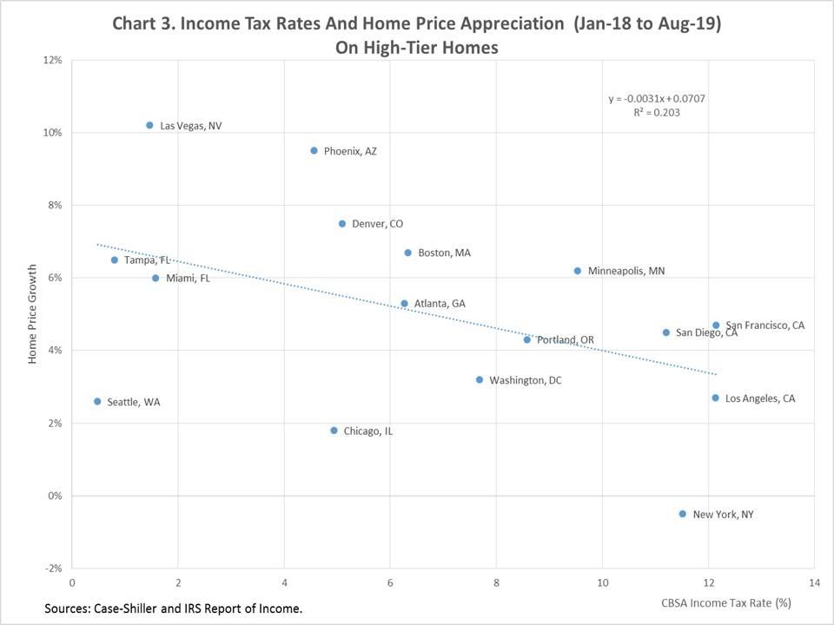

One might ask, if TCJA has eroded demand for homes as of Aug-19 is this likely to continue? In Charts 4 and 5 we look at the HPA pattern over time for the two cities on the extreme ends of Chart 1. In the two charts below, we look at year-over-year growth rates.
In New York City, year-over-year HPA has been declining since TCJA inception. The pre-TCJA ends at Point a and post-TCJA picks up at Point b. The trend is hard to ignore. In Chart 4 we review identical data for Phoenix. Here we can see that home price growth post-TCJA has been consistently stronger than pre-TCJA. Strong demand to live in Phoenix has outweighed the reduced demand from the reduced financial value of owning a home since TCJA inception and HPA has remained strong. The top marginal tax rate in Arizona is 4.54%. The point is that in Phoenix the financial value of the MID deduction was never very large because it is a mid-range SALT state and relative to California home prices are low.


